CENTRAL PROCESSING, LLC CENTRAL PROCESSING, LLC

Please highlight and complete every blank below as well as (Your Initials) and (Your Full Name) and (Date) near and at the end of this Agreement (your typed initials are your initials and your typed full name is your signature). Then save this Agreement and e-mail from your ProtonMail e-mail account to cp4us@pm.me your Agreement, your notarized USPS Form 1583, a copy of your driver’s license, and a copy of your auto registration—you will not be refunded if you make a payment without submitting these. You will be e-mailed a copy of this Agreement bearing your assigned Attention Code at the bottom of the mailing addresses at the end of this Agreement.

2885 Sanford Ave SW #44631 4600 Mobile Hwy #9, PMB 138

Grandville, MI 49418 Pensacola, FL 32506

cp4us@pm.me cp4us@pm.me

**MAILBOX SERVICE AGREEMENT**

**(Addendum to Purchase Agreement)**

CUSTOMER NAME: ____________________________________________________

COMPANY: ____________________________________________________

ADDRESS: ____________________________________________________

PHONE: _______________ WORK PHONE: _______________

E-MAIL ADDRESS: ____________________________________________________

This Mailbox Service Agreement (“Agreement”) is executed under the terms set forth herein between the customer identified above (“Customer”) and CENTRAL PROCESSING, LLC (“Provider”) for the use of and services related to the rented mailbox (the “Mailbox”) at either or both of the addresses listed above, the first of which is rented from Mailbox Forwarding, Inc. (left address) and the second of which is rented from The UPS Store (right address).

Customer agrees that Customer will not use either of Provider’s addresses or any of Prover’s services for any unlawful, illegitimate or fraudulent purposes or for any purpose prohibited by U.S. postal regulations or for anything relative to mass mailing (sending, receiving, or returning). Customer further agrees that any use of the Mailbox shall be in conformity with all applicable federal, state and local laws. Customer acknowledges that only those individuals or entities listed on U.S. Postal Service Form 1583 (“Form 1583”) are authorized to receive mail or packages at the Mailbox and that Customer’s submission of this Agreement without an accompanying completed, signed and notarized Form 1583 does not authorize Provider to forward mail or packages to Customer. Customer acknowledges that Provider’s Grandville, MI address is used for fee-free scanning and e-mail forwarding of mail received and that Provider’s Pensacola, FL address is used for fee-based mail and package forwarding (via USPS mail and other courier services). Accordingly, Customer further agrees to use Provider’s Grandville, MI address for scan-able mail only (no packages) and/or to use Provider’s Pensacola, FL address for other mail and packages. Customer further acknowledges and agrees that mail or packages bearing either of the Provider’s mailbox addresses but not bearing Customer’s assigned Attention Code (“Attention Code”) will not be forwarded to Customer.

This Agreement and Form 1583 shall remain confidential, except that this Agreement and Form 1583 may be disclosed upon request of any law enforcement or other governmental agency or when legally mandated. Upon request, Customer agrees to complete all necessary documents, including Form 1583 and any required forms. Customer further agrees to sign an updated version of this agreement upon request, provided that such request shall not exceed once per year.

Customer agrees to pay applicable monthly service fees. Mailbox service fees are all due and payable in advance and Customer agrees that Provider may hold mail and packages pending payment. There will be ***NO*** pro-rations or refunds for cancellation of any service. Mailbox service fees and other related fees stated herein are subject to change. Customer authorizes Provider to charge Customer for a minimal handling fee plus the fee or fees incurred for the forwarding or returning of any mail or packages for each instance. In the event that Customer receives an unreasonable volume of mail or packages at the Mailbox according to the judgement of either Provider or the provider of either mailbox address, Customer authorizes Provider to charge Customer for any additional charges Provider incurs by the provider of either mailbox address, and Provider reserves the right to terminate this agreement with no refund. Customer agrees not to display or cause or allow to be displayed either of Provider’s mailbox addresses on any material or envelopes for mass-mailing purposes. Customer further agrees not to stop and resume paying applicable monthly service fees repeatedly. In the event that Customer stops and resumes paying more than once in any twelve-month period, Customer authorizes Provider to charge Customer for any months during the same twelve-month period for which Customer did not pay applicable monthly service fees.

Upon expiration, cancellation or termination of this Agreement, Provider will forward Customer’s mail and packages for thirty (30) days, provided Customer pays the postage, packaging materials, and forwarding fees in advance. Thereafter, if Customer requires necessary arrangements but payment is not made in advance to forward mail or packages upon the expiration, cancellation or termination of this Agreement or expiration of any pre-arranged forwarding period (“Final Service Date”), Customer’s mail and packages may be refused or returned to sender. Provider may discard or destroy any mail or package delivered to or remaining at either of Provider’s mailbox addresses more than thirty (30) days after the Final Service Date or, in the case of mail or packages which require a signature from the provider of either mailbox address as a condition of delivery, more than ninety (90) days from the Final Service Date.

The term of this Agreement shall be the initial period paid for by Customer and any renewal period paid for by Customer from time to time. Renewal of this Agreement for additional terms shall be at Provider’s sold discretion.

Customer agrees that Provider may terminate or cancel this Agreement for good cause at any time by providing Customer thirty (30) days’ written notice. Good cause shall include but is not limited to: (1) Customer uses the Mailbox for unlawful, illegitimate, fraudulent, or mass-mailing purposes; (2) Customer fails to pay monies owed Provider when due; (3) Customer receives an unreasonable volume of mail or packages; (4) Customer engages in offensive, abusive or disruptive behavior toward other customers, agents, or employees of Provider or of the provider of either mailbox address; and (5) Customer violates any provision of this Agreement. Customer acknowledges that, for the purpose of determining good cause for termination of this Agreement as provided herein, the actions of any person authorized by Customer to use the Mailbox will be attributed to Customer.

Any written notice to Customer required or permitted under this Agreement shall be deemed delivered twenty-four (24) hours after electronic (e-mail) or mailed (USPS) notice has been issued to Customer or at the time personally delivered to Customer.

As Customer’s authorized agent for receipt of mail, Provider will accept all mail, including registered, insured and certified items. Unless prior arrangements have been made, Provider shall be obligated only to accept mail or packages. Customer authorizes Provider to charge Customer for any fee Provider incurs either directly or by the provider of either mailbox address, such as storage fees or any postage or other fees associated with the return of any mail or packages. C.O.D. items will be accepted ***ONLY*** if prior arrangements have been made and payment in advance is provided to Provider.

Customer agrees to protect, indemnify, defend and hold harmless Provider, Mailbox Forwarding, Inc., The UPS Store USA, Inc., and their respective affiliates, subsidiaries, parent organizations, franchisees, officers, directors, agents, and employees from and against any and all losses, damages, expenses, claims, demands, liabilities, judgements, settlement amounts, costs, and causes of action of every type and character arising out of or in connection with the use or possession of the Mailbox, including without limitation any demands, claims and causes of action for personal injury or property damage arising from such use or possession, from failure of the U.S. Postal Service or any commercial courier service to deliver on time or otherwise fail to deliver any items (mail, packages, etc.), from damage to or loss of any package or mail or to or of the Mailbox contents by any cause whatsoever, and from any violation by Customer of applicable federal, state or local laws.

Customer acknowledges and agrees that Provider is unrelated to the provider of either mailbox address and that Provider is not responsible for any acts or omissions of the provider of either mailbox address.

CUSTOMER HEREIN AGREES THAT THE TOTAL AMOUNT OF LIABILITY OF PROVIDER AND/OR THE PROVIDER OF EITHER MAILBOX ADDRESS, IF ANY, FOR ANY AND ALL CLAIMS ARISING OUT OF OR RELATED TO THIS AGREEMENT SHALL NOT EXCEED $100.00 IN THE AGGREGATE REGARDLESS OF THE NATURE OF THE CLAIM.

(Your Initials)

Customer agrees to use the mailing address format set forth below without modification. Delivery by commercial courier services must be made to the street address only. The terms “Suite,” “P.O. Box” or “Box” cannot be used in either address to refer to the Mailbox number. Any mail or package received by the provider of either mailbox address that includes the terms “Suite,” “P.O. Box” or “Box” may be returned to sender, at the option of the provider of either mailbox address (use of any other format or name or address may cause mail and packages not to be forwarded to you). Customer shall provide two forms of valid identification with this Agreement, one of which shall include a photograph (satisfied by e-mailing to cenpro4u@gmail.com an accompanying completed, signed and notarized Form 1583 and a high-definition copy of each of the two forms of identification listed thereon).

Customer acknowledges and agrees that any mail or packages bearing either of Provider’s mailbox addresses but not bearing “ATTN:” followed by Customer’s assigned Attention Code below the City, State and ZIP Code will not be forwarded to Customer. Customer states and declares that Customer’s typed initials, above, are Customer’s initials and that Customer’s typed full name, below, is Customer’s signature.

Customer (Buyer) expressly accepts the terms of the **Purchase Agreement** of Provider’s (Seller’s) website.

This Agreement may not be amended or modified except in writing and signed by both parties.

Customer’s mailing address shall be:

Scan-able Mail Only (forwarded via e-mail):

CENTRAL PROCESSING, LLC

2885 Sanford Ave. SW #44631

Grandville, MI 49418

ATTN: (YOUR ATTENTION CODE)

Other Mail and Packages (forwarded via USPS or other courier service):

CENTRAL PROCESSING, LLC

4600 Mobile Hwy. #9, PMB 138

Pensacola, FL 32506

ATTN: (YOUR ATTENTION CODE)

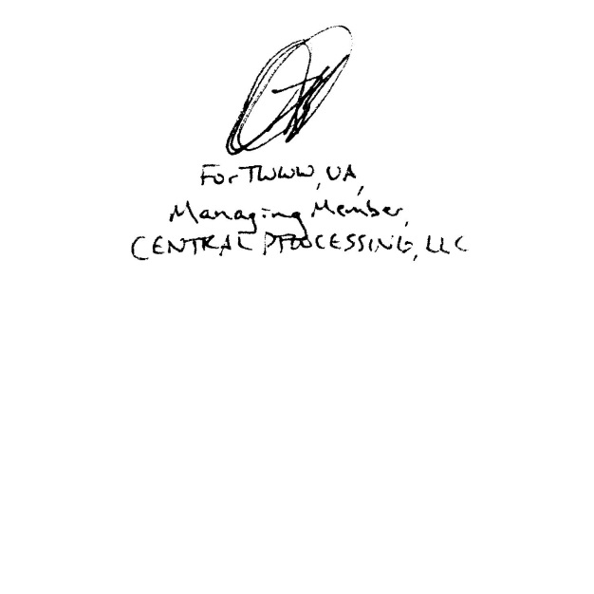

(Your Full Name)

(Date)